RESUME

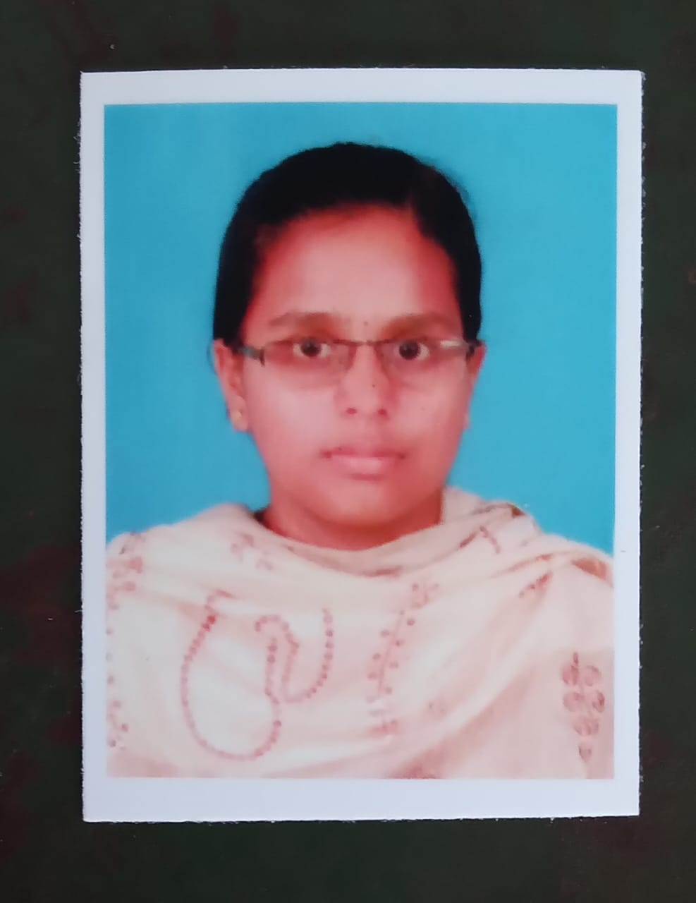

Udayachandrika k.s.

D/o R K.sivakumar,

21,south ramalingapuram,

Chennimalai(via),

Erode(dt) .

9976588991

CAREER OBJECTIVE :

To work in a innovation and challenging environment extracting the best act of me, enhancing my professional skills with learning and experience for career growth.

ACADEMIC QUALIFICATION :

|  |  |  |  |  |
| --- | --- | --- | --- | --- |
| COURSE | INSTITUTION | UNIVERSITY  OR BOARD | YEAR OF PASSING | AGGREGATE |
| BSC.IT | NAVARASAM ARTS AND SCIENCE COLLEGE FOR WOMEN, ERODE | BHARATHIYAR UNIVERSITY | 2024 | 78.28 % |
| HSC | Dr.MGR HIGHER SECONDARY SCHOOL,RAMAVARAM | STATE BOARD | 2021 | 59% |
| SSLC | Dr.MGR HIGHER SECONDARY SCHOOL,RAMAVARAM | STATE BOARD | 2019 | 48% |

SKILLS :(TECHNICAL SKILLS)

* Java
* Html

STRENGTH:

Easily comined with others,Self learner,Multitasking person

EXTRA CURRICULAR ACTIVITIES:

* Got some prizes in Yoga competitions during school days.
* Participation in national level seminars

PERSONAL DETAILS:

DOB : 25.03.2002

Parents name : Mr.R.K.Sivakumar

Mrs.S.vijayalakshmi

Mother’s Occupation : Farmer

Nationality : Indian

Languages Known : Tamil, English

Hobbies : Cooking,Travelling,Gardening,Puzzle solving

DECLARATIONS:

I hereby declare that the above details are true to the best of my knowledge. If I have been recruited, I will be sincere and dedicated to my job.

PLACE : Arachalur

( K.S.Udayachandrika)